Week 5 Practical
Initial configuration

Screenshot of completed topology
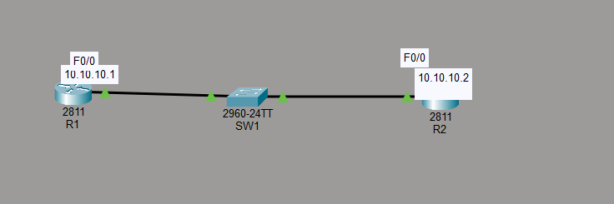

28.Configuration of hostname for Router 1
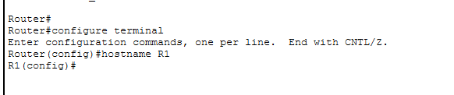
29.cofiguration of hostname for Router 2
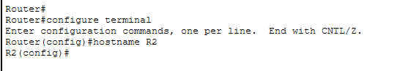
30. configuration of hostname for switch 1
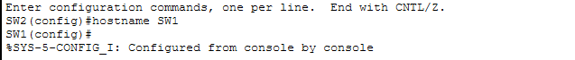
31.Configuring IP address for R1
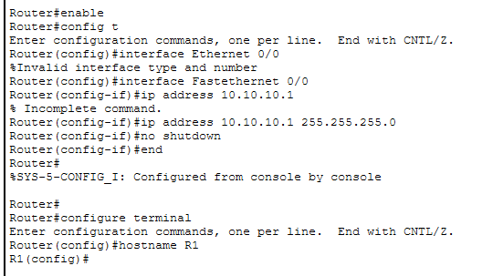
32. Configuring IP address for R2
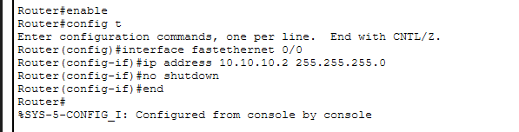
33.Configuring SW1 IP address
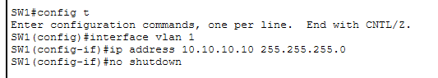
34. Pinging SW1 to R2
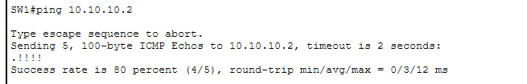

CDP configuration

36. Verify the directly attached Cisco neighbours using CDP.
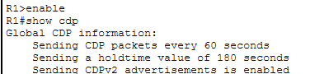
37. Prevent R1 from discovering SW1 via CDP : disable CDP on R1's interface facing SW1 specifically ('no cdp enable' on that interface), not globally, since Task 38 below re-enables CDP globally.
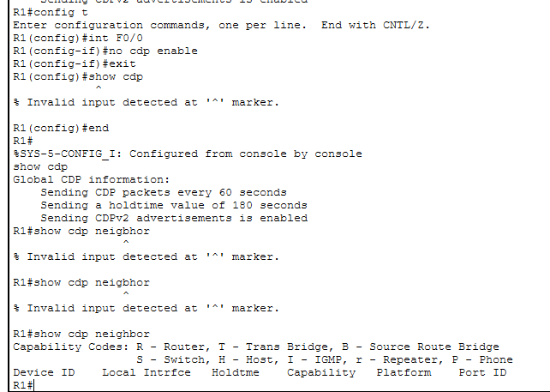
38. Flush the CDP cache on R1 with 'no cdp run' then 'cdp run' in global configuration mode.
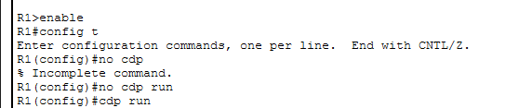
39. Verify that R1 can no longer see SW1 via CDP (the interface-level disable from Task 37 should still be in effect).
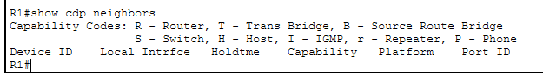
Switch troubleshooting
40. Verify the status of the switch port connected to R2 with 'show ip interface brief' : it should show up/up.
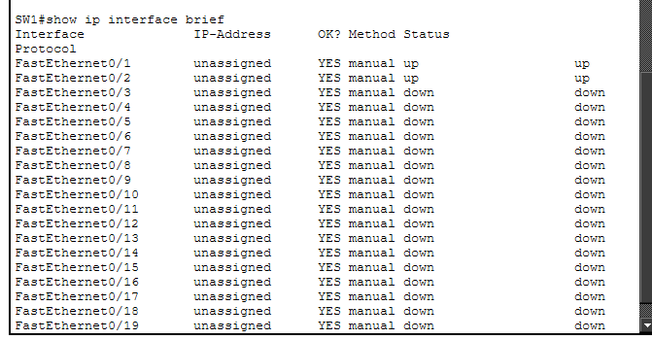
41. Shut down the interface connected to R2 and check the status again : it should show administratively down/down.
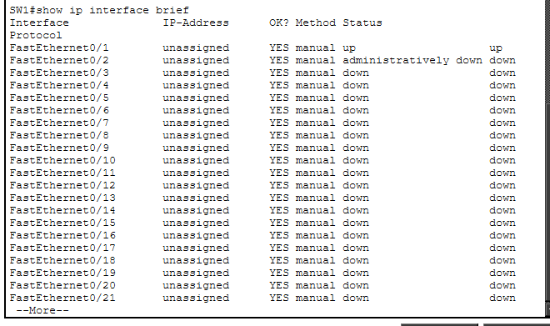
42. Bring the interface back up and verify its speed and duplex settings.
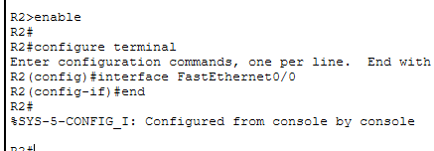
43. Set the duplex on SW1's interface to half (leave R2 as-is) and verify the state of the interface.
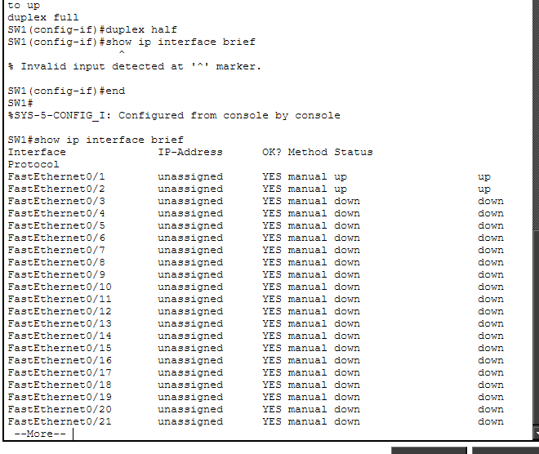
44.set duplex

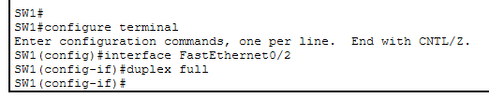
45. Setting speed to 10 mhps
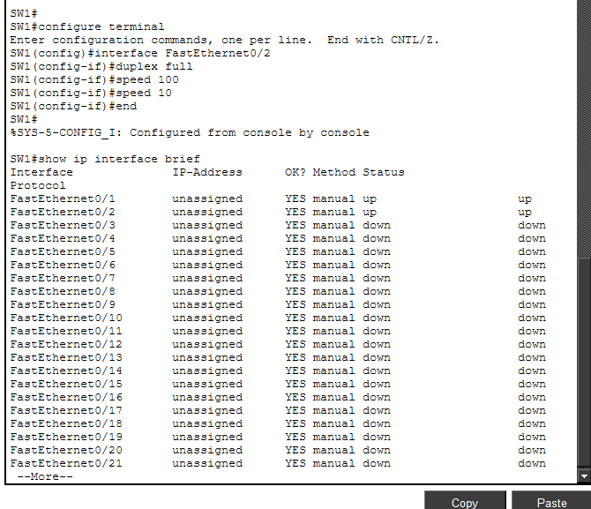
46. Check whether the interface on R2 is still operational, and note its status

The interface for R2 is up and manually configured even with 10mhps , it works well

46. When you set a duplex mismatch between SW1 and R2, what symptoms did you observe, and why does a mismatch cause this behaviour?
When you set a duplex mismatch between SW1 and R2, the link stayed up but performance dropped noticeably. You would have seen slow throughput, packet loss, and a rise in collision or error counters on the interfaces. This happens because one side in full duplex tries to send and receive at the same time, while the half-duplex side only allows one direction at once. The mismatch leads to late collisions and retransmissions, which degrade network efficiency even though the physical connection remains active.

